Process & Decision Documentation

Side Quests and A4 (Individual Work)
- Updated side quest 6 by adding debug mode and strawberry collecting score

Role-Based Process Evidence
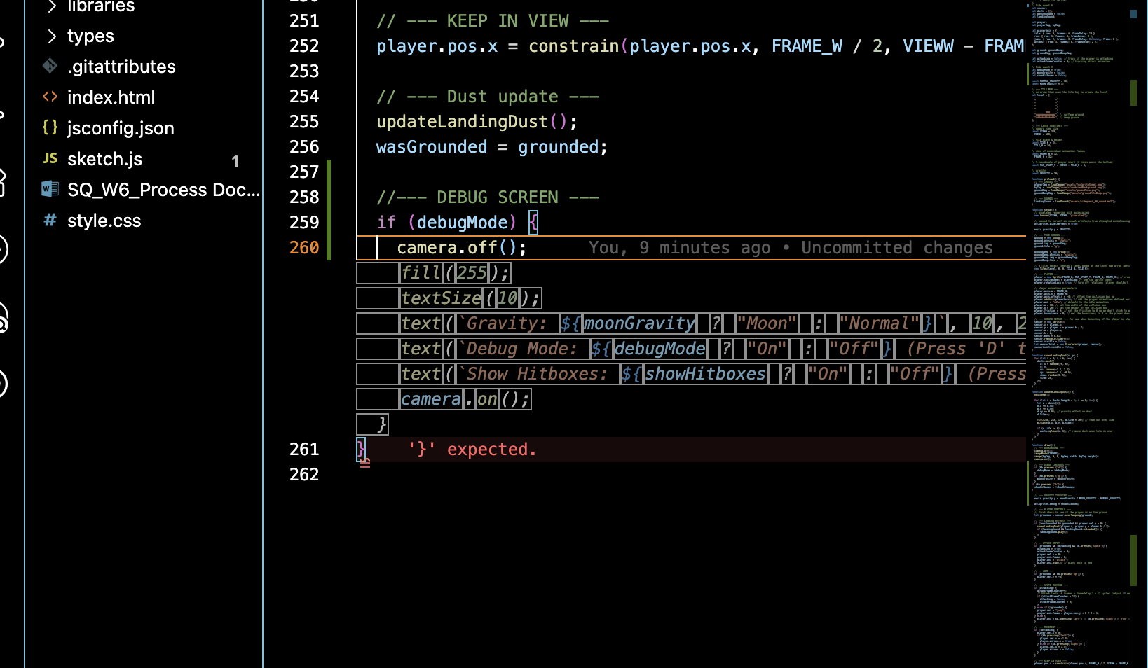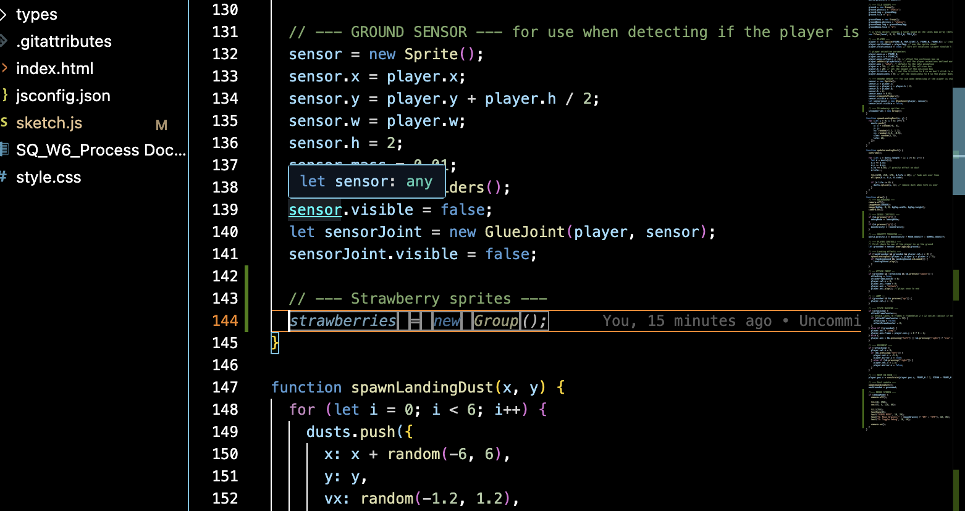
Writing code on vsc
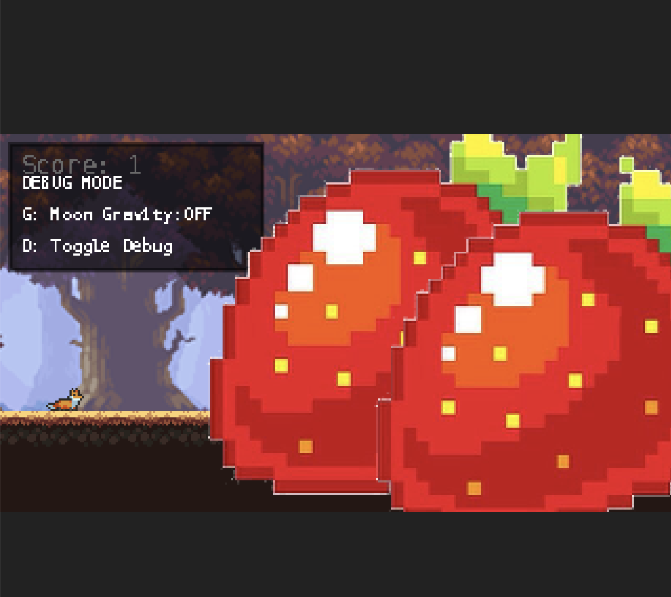
Game screen before debugging

GenAI Documentation

If GenAI was used (keep each response as brief as possible):
Date Used: March 23, 2026
Tool Disclosure ChatGPT 5.2
Purpose of Use: Making my ideas into codes and debugging.
Summary of Interaction: From making my ideas of how the debug toggle would work and creating strawberry collecting feature, GenAI helped me to make ideas into codes and debug the errors that came up.
Human Decision Point(s): I determined all of the UI aspect of the debug panels and strawberries.
Integrity & Verification Note: I made iterations based on my decisions and ethics. I verified by testing the game in every code implementation.
Scope of GenAI Use: The feature mechanics and UI aspects were decided by me and not GenAI
Limitations or Misfires: The GenAI didn’t have all context of the game so it had limitation to how the UI should look like for the strawberry collection so I had to decide the size, position, image and etc.

Appendix
Me:I want to add a strawberry collectible that adds in the game screen. Help me to build this on top of my game js file.
AI:
Nice—this is a perfect feature to add. I’ll walk you through a clean, working setup.
corner

🍓 1. Create the strawberry group
At the top of your sketch.js (with your other globals):
let strawberries;
let score = 0;
Inside setup():
strawberries = new Group();

🍓 2. Create strawberry sprites
Still inside setup(), add a few strawberries:
new strawberries.Sprite(200, 200, 20, 20);
new strawberries.Sprite(400, 150, 20, 20);
new strawberries.Sprite(600, 250, 20, 20);
👉 If you have a strawberry image, use:
strawberries.img = 'strawberry.png';
strawberries.scale = 0.5;

🍓 3. Detect collection
Inside your draw() function:
player.overlaps(strawberries, (player, berry) => {
berry.remove(); // remove strawberry
score++; // increase score
});

🧮 4. Draw the score (top-right corner)
Still in draw():
push();
fill(255);
textSize(20);
textAlign(RIGHT, TOP);
// adjust depending on your canvas size
text("🍓 " + score, width - 20, 20);
pop();

⚠️ IMPORTANT (camera issue fix)
If you are using a camera (p5play default), the text might move with the world.
To keep UI fixed on screen, wrap it like this:
camera.off(); // draw UI in screen space
push();
fill(255);
textSize(20);
textAlign(RIGHT, TOP);
text("🍓 " + score, width - 20, 20);
pop();
camera.on(); // go back to world

✅ Final result
You now have:
- 🍓 collectibles that disappear on touch
- 📈 score increases
- 🖥 score UI fixed in top-right

If you want next level polish, I can help you:
- animate the strawberries (spinning ✨)
- add a berry counter like 3 / 10
- or make them respawn/reset per level
Just tell me 👍
Me: I want to adjust the strawberry size because it is too big right now. Which line should I be changing?
AI:
To adjust the size of the strawberries, you need to change the scale property in the strawberry group setup. Here's how:
In your sketch.js file, find this section in the setup() function:
javascript
// --- Strawberry sprites ---
strawberries = new Group();
strawberries.collider = "static";
strawberries.img = strawberryImg;
strawberries.scale = 0.5; // ← Change this number!
How the scale works:
- 0.5 = 50% of original size (smaller)
- 1.0 = 100% of original size (normal)
- 2.0 = 200% of original size (bigger)
- 0.25 = 25% of original size (much smaller)
Just change that one line and refresh your browser to see the new strawberry size! 🍓

